ASR 6350

1.       Upload Shipment HU

-          After the import of the HU# into the WMS , the screen will appear those HU# has not been load into the container.

2.       Outstanding HU for loading

-          To add in field for filter “ MOT “  & “Shipment No. “

3.       RF loading Module.

-          WMS will block for the next scanning when Error Message prompt out, able to proceed the next scanning when the “OK” button is press.

**Date: 2016.10.19**

**WMS Changes:**

1. Upload Shipment HU

System auto filter HU that has not loaded (which is Plan ID is blank)

Eg. Upload 5 HUs

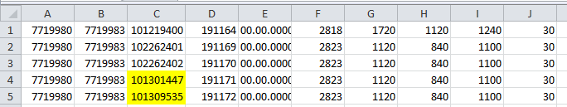

2 highlighted HU was loaded.

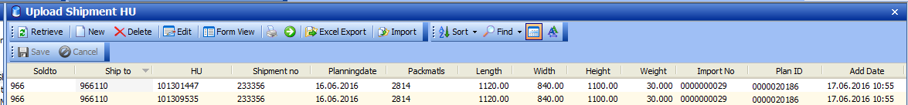

After uploaded:

System will prompt Import status:

Inserted =3 Hus, Updated =2 HU.

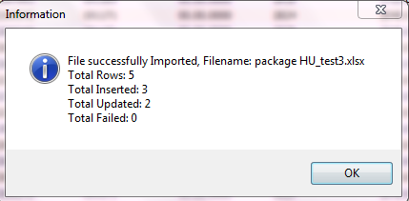

Screen filter HU has not loaded:

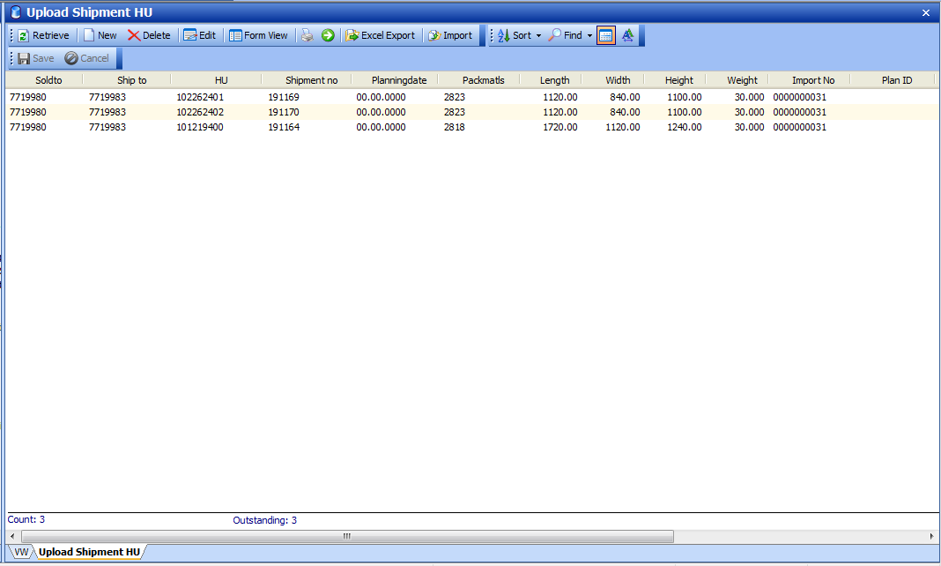

Display Outstanding HU count.

1. Report – Outstanding HU for loading

Added Report criteria

MOT – Mode of transport

Shipment range – From shipment # , to Shipment #

